Functional Model

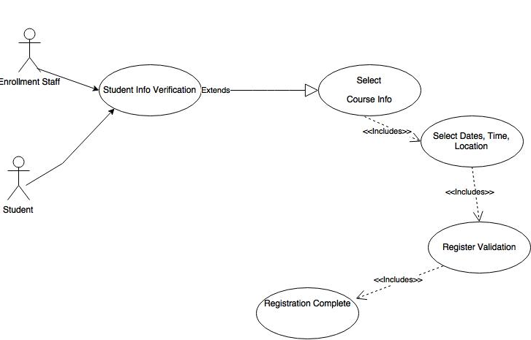

Use Case Name:  Student Class Registration | ID: | Importance Level:  High
Primary Actor:  Student and Staff | Use Case Type:  Essential
Stakeholders and Interests: Students and Staff

Brief Description: Students registering for classes via SIS

Trigger: Students registering for classes via SIS alone or with the help of enrollment staff

Type: External and Internal

Relationships:

- Association: Student and Staff
Include: Course info, Class location, time and date
- Extend: student validation

- Generalization:

Normal Flow of Events:
1.Student validates identity
2.Selects Course
3.Location, date, and time
4.Registration confirmation
5.Registaration complete

SubFlows:
S1-Staff assisted
1.Staff validates student’s identity
2.Selects Course
3.Location, date, and time
4.Registration confirmation
5.Registaration complete

Alternate/Exceptional Flows:

